DONATIONS LIST
(Easy to post on your fridge or near your recycling bin!)
- Brass Fasteners  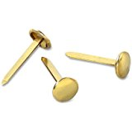 | - Pipe Cleaners  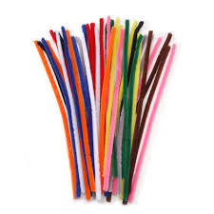 | - Paper Towel Tubes
- Packing Tape  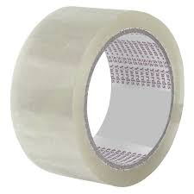 | - Masking Tape  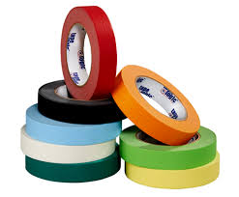 | - Cardboard  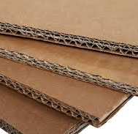
- Bottle caps  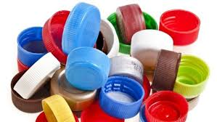 | - Styrofoam Balls | - Hole Punchers  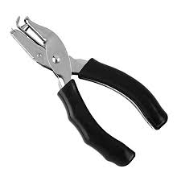
- Newspaper | - Knick-knacks | - Yarn, string, etc.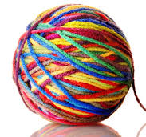
- Paper and Plastic bags  - Tacky glue  - Small Toys  - Crafts supplies | - *Clean* Yogurt cups and other like containers | - Storage supplies (bins, drawers)  - We accept all sorts of cool stuff!
Thank you!
The Art Room

